**Objective:-** Create a Profile page/s(Personal website).

**HTML Code :-**

<!DOCTYPE html>

<html>

<head>

<title>My Profile</title>

<style>

body {

font-family: Arial, sans-serif;

margin: 0;

padding: 0;

}

#header {

background-color: #333;

color: #fff;

padding: 20px;

text-align: center;

}

#profile-image {

width: 200px;

height: 200px;

border-radius: 50%;

margin: 20px auto;

display: block;

}

#work-slider {

margin-top: 30px;

text-align: center;

}

#work-slider img {

max-width: 100%;

height: auto;

}

#description {

margin-top: 30px;

text-align: center;

}

#contact {

margin-top: 30px;

text-align: center;

}

#map {

height: 300px;

margin-top: 30px;

}

</style>

</head>

<body>

<header id="header">

<h1>My Profile</h1>

</header>

<img id="profile-image" src="./assets/Profile.png" alt="Profile Image">

<section id="work-slider">

<h2>Work Done</h2>

<div class="slider-container">

<h2>Calculator :-</h2>

<img src="./assets/Work_1.png" alt="Work 1">

<h2>Hotstar Clone :-</h2>

<img src="./assets/Work_2.png" alt="Work 2">

<h2>Netflix Clone :-</h2>

<img src="./assets/Work_3.png" alt="Work 3">

<h2>Weather App :-</h2>

<img src="./assets/Work_4.png" alt="Work 3">

</div>

</section>

<section id="description">

<h2>About Me</h2>

<p>Hii , I am <strong>Aryan Langhanoja</strong> , a enthusiast for learniing web development.</p>

</section>

<section id="contact">

<h2>Contact Me</h2>

<p>Email: aryanlanghanoja233@mail.com</p>

<p>Phone: +91 9404806497</p>

</section>

</body>

</html>

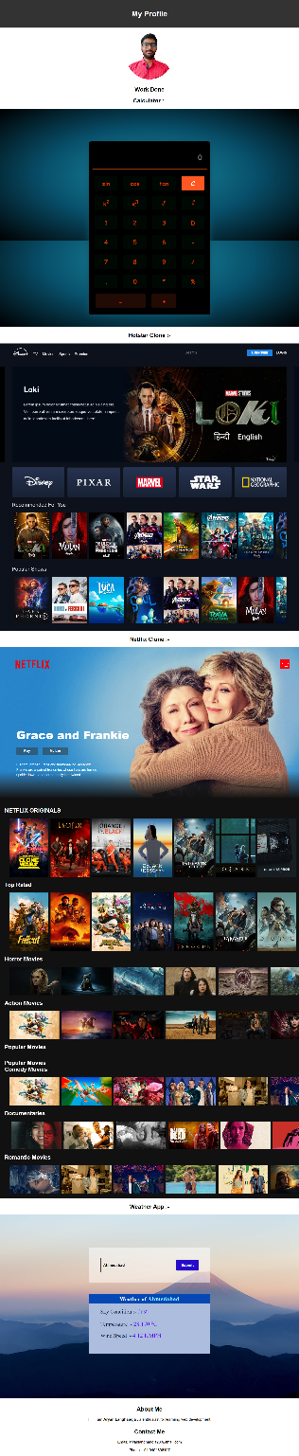**Output :-**